|  |
| --- |
| Experiment - 1 |

* Data Validation :- Data validation is the process of checking data to ensure it meets specific criteria or standards before it's accepted into a system. It prevents errors and inconsistencies by verifying things like format, range, and type. This ensures data quality and reliability for accurate analysis and decision-making.
* Steps to apply in Excel :- Here are the steps to apply data validation in Excel summarized concisely:

1. **Select Cells:** Choose the cells where you want to apply data validation.

1. **Open Validation Dialog**: Access the "Data Validation" dialog from the "Data" tab.

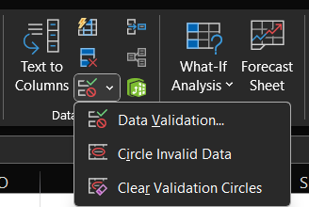

1. **Choose Criteria**: Select the type of validation criteria (e.g., Whole Number, List).

1. **Set Rules**: Define specific rules (e.g., range, list of values) based on the chosen criteria.

1. **Optional Input Message**: Optionally, provide a message to guide users when selecting a validated cell.

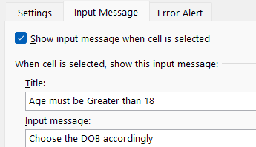

1. **Optional Error Alert**: Optionally, set up an error message to inform users if invalid data is entered.

1. **Apply Validation**: Click "OK" to apply the data validation rules to the selected cells.

1. **Test Validation**: Enter data into the validated cells to ensure the validation rules are enforced correctly.

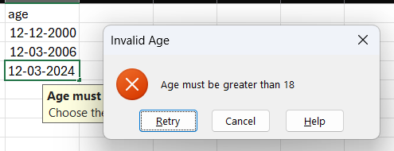

* **Pivot Table** :- Pivot tables in Microsoft Excel are powerful tools used for summarizing, analyzing, and presenting large amounts of data quickly and efficiently. They allow users to extract insights from data by arranging and summarizing it in a customizable format.
* **Features** :- Here's a succinct breakdown of the pivotal features of pivot tables in Excel:

1. **Data Summarization:** Pivot tables can summarize large datasets by grouping and aggregating data based on specified criteria, such as sums, averages, counts, or other mathematical functions.
2. **Dynamic Updating:** Pivot tables automatically update when the source data changes, ensuring that your analysis remains current without the need for manual adjustments.
3. **Drag-and-Drop Interface**: Users can easily rearrange and customize pivot tables by dragging and dropping fields into different areas, such as rows, columns, values, or filters, allowing for flexible data analysis.
4. **Filtering and Slicing**: Pivot tables enable users to filter and slice data dynamically, allowing for focused analysis of specific subsets of data based on various criteria.
5. **Calculations and Formulas**: Users can create custom calculations and formulas within pivot tables to derive new insights or perform complex analyses without altering the source data.
6. **Visual Representation**: Pivot tables can present summarized data visually through charts and graphs, providing clear and intuitive representations of trends and patterns within the dataset.
7. **Drill-Down Capabilities**: Users can drill down into pivot table data to view underlying details and explore granular information, facilitating deeper analysis and understanding.
8. **Data Consolidation:** Pivot tables can consolidate data from multiple sources or sheets within Excel, making it easier to analyze and compare information from different datasets.